Sanjana Jogdand

21111646

3BBA D

Subject- Fundamentals of Product Management

Q1. Which 5 products can be categorized in the small business category?

Answer- A small firm is one that has fewer employees and requires less in the way of supplies, labor, or capital outlay to operate.

It ends up being the main driver of the country's economic expansion. In this situation, we must make a one-time investment in structures, machinery, or we may even decide to lease the equipment. Examples from India include small-scale industries and businesses producing pens, candles, chocolate, toothpicks, and other goods.

Following are the 5 products that can be categorized in the small business category –

* Cakes
* Cosmetic Products
* Battery
* Glass and Ceramics
* Jute goods and products

Q2. What are the 5 characteristics of product strategy?

Answer-

The following are the 5 characteristics of product strategy –

• Product Vision

• Product Mission

• Product Strategy

• Product Plans

• Product Roadmap

Q3. What are the 5 primary activities in Porter’s Value chain?

Value chains boost an organization's productivity, enabling it to deliver the best value at the lowest possible cost. A value chain's main goal is to provide a business an advantage by boosting productivity and cutting expenses. An investigation of the value chain's links, interconnections, and other patterns can show these. 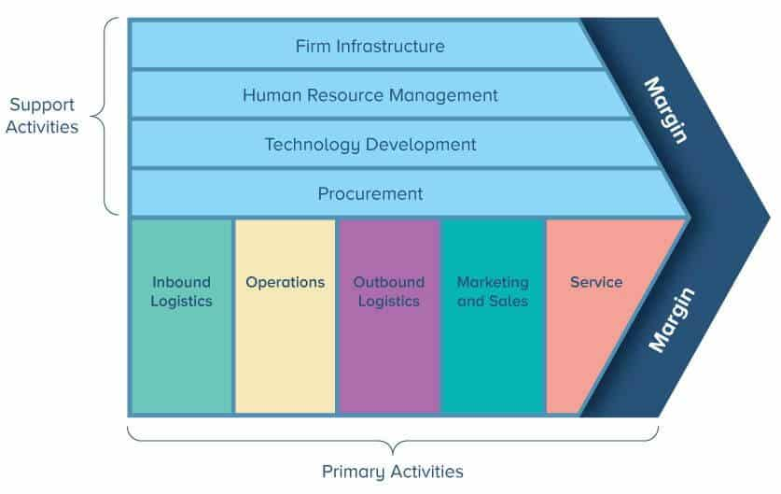

Q4. What are the 5 forces in Porter’s competitive strategy?

Answer-

According to Porter, there are five forces that primarily drive rivalry within a particular industry. They are as follows-

* Supplier Strength.
* Rivalry in a healthy way
* Consumer Power.
* The threat of Replacement.
* A potential new entry

Q5. List 5 business growth strategies.

1. Product Expansion and Diversification - Creating new products or enhancing existing ones with new features can be part of a very effective business expansion strategy. By creating new products, you can reach markets that were previously uninterested in your brand.
2. Advertising current items to unexplored markets.
3. Market disruption is when a company acts completely differently from everyone else after entering a well-established market that is frequently dominated by a limited number of historical brands.
4. Mergers with others, Acquisitions
5. Strategic partnerships with brands